Contents
1. Fast API 2
1.1. Need for APIs: 2
1.2. What is Fast API: 6
1.3. Flask API vs Fast API 7
2. HTTP methods: 9
2.1 GET method (Retrieve): 10
2.2. POST method (Create): 11
2.3. PUT (Update): 12
2.4. Delete (Delete): 13
3. Docker: 15

Fast API
Three parts:
- Fundamentals of Fast API
- Build APIs for ML model using Fast API
- Deployment of API using docker on AWS.
An API, or Application Programming Interface, is a set of rules, protocols, and tools that allows different software applications or components to communicate and exchange data with each other seamlessly.
APIs connect frontend with backend taking the requests and delivering the output in specific format following protocols.
Great analogy to understand would be customer waiter Kitchen, waiter is the API here.

Need for APIs:
- In monolithic architecture frontend and backend are in single software application, i.e. both the frontend and backend files are in single code base in single project folder. This makes the frontend and backend coupled together tightly where the request from the front end is sent to the backend where the function is written in the backend which handles the request with input arguments are execute connection with database and returns the data to the frontend. i.e. direct Database Backend Frontend.
Issues with Monolithic Architecture.
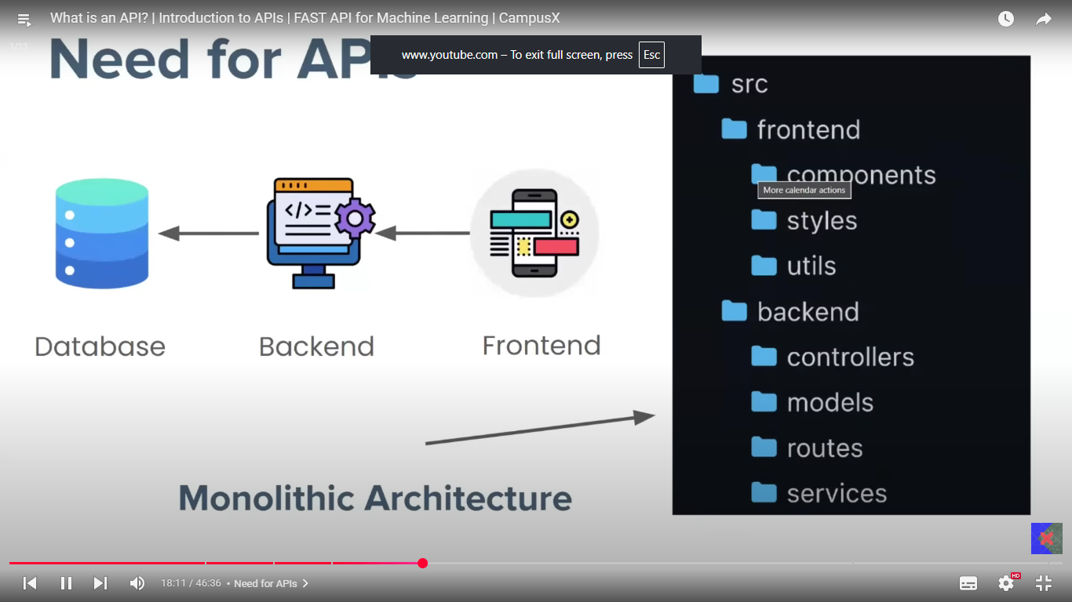
Suppose we need to serve data to different user from our database, e.g. IRCTC would be sharing data to MakeMyTrip, Yatra, ixigo etc. in this case we can’t directly give access of our database to these users. So other logical thing to do would be to give access of our backend meaning the code functions or classes which handles request form frontend and returns the data from the database to frontend, same functions from the backend would connect to the users and handles requests from these but these can not be done, as in monolithic architecture the frontend and backend are tightly connected as everything is a part of one integrated application.
Solution for above issue, Here comes the role of API:
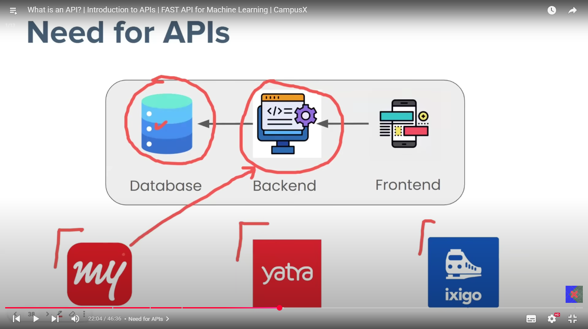
You decouple entire software application, writing frontend and backend codes separately. And now backend can be accessible easily now to request. So, what happens here, publicly available functions are available on endpoints (specific URL or location where an API receives requests) this function interacts with the backend where the same already available functions which interacts with database and requests works as normal and returns the data which then API returns to the endpoints then to the source. Here you did two things different, first decoupled the entire application and second make backend or at least some functions of backend made available publicly. And even your frontend which is a different software application now interact with the backend trough API calls.
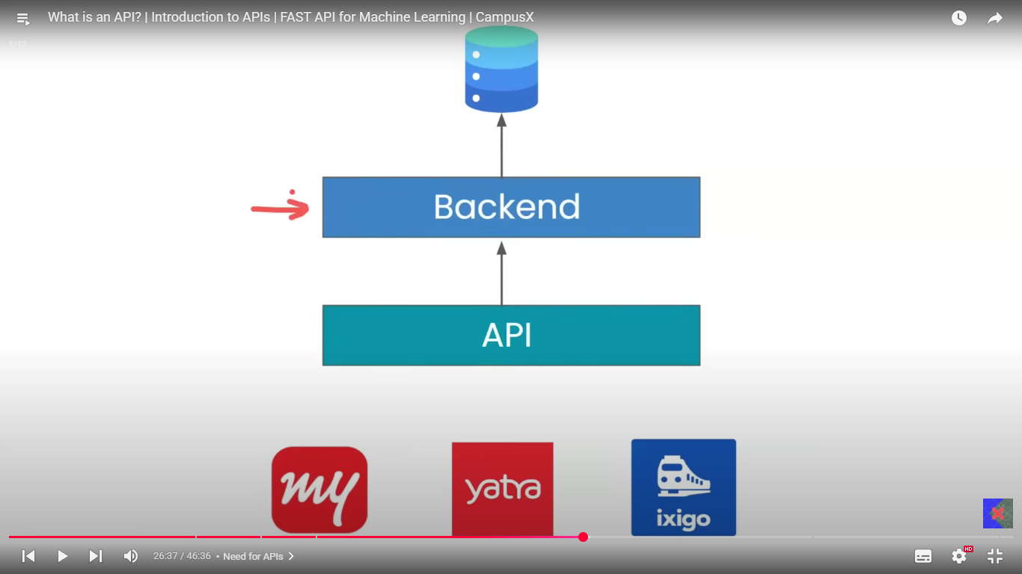
APIs follow HTTP protocol and has output data format as JSON.
- For multiple device application like Android, windows and IOS front end of the applications are written in their respective languages and then one backend serves all the different frontends with JSON output structured data with the http request protocol.
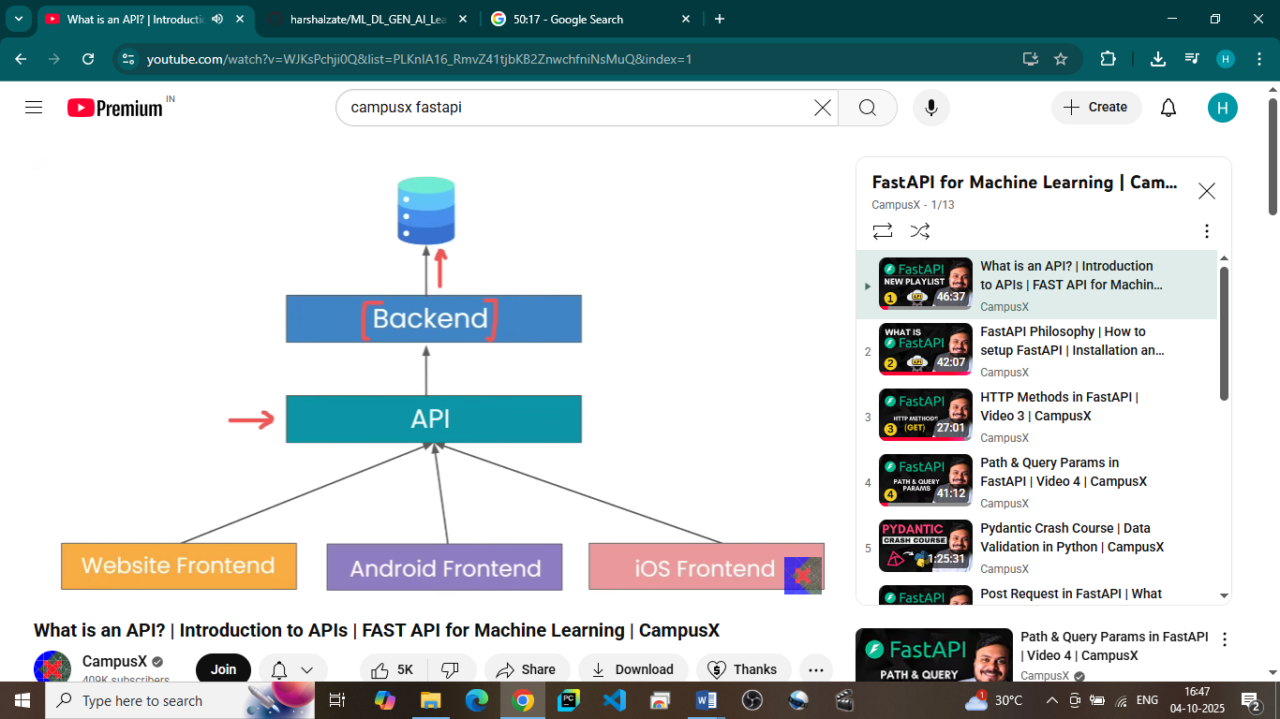
Perspective with ML domain.
Similar to software monolithic architecture, ML model interacts with backend through functions in backend and backend receives those request directly from frontend are these are coupled tightly.
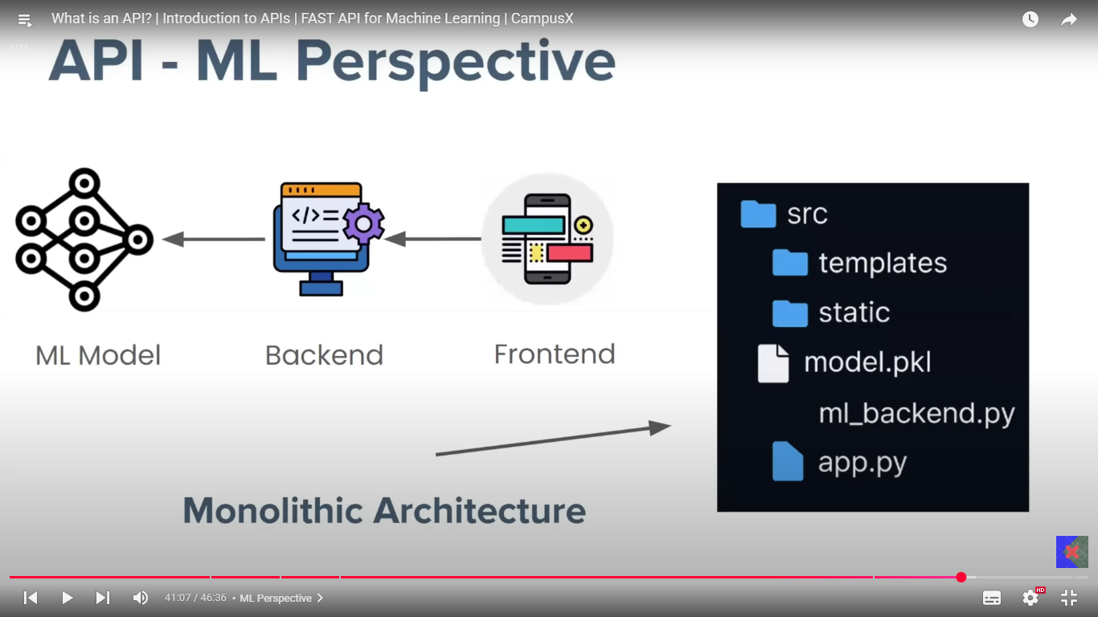
Now with APIs the exactly same change happens in ML applications, the only difference is instead of database the backends interacts with model file(binary file)
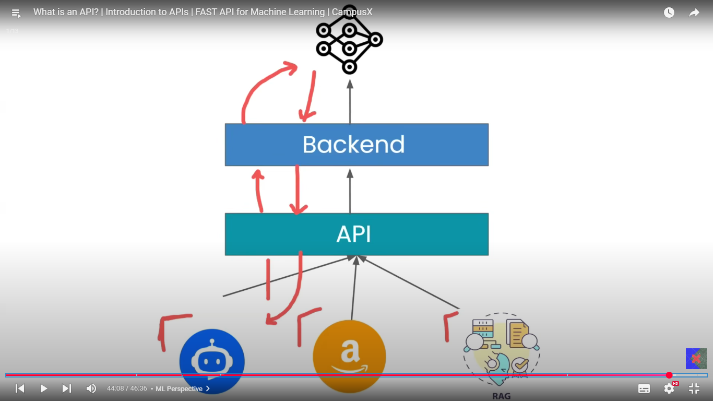
  - What is Fast API: modern high-performance web framework for building APIs with python.
It is based on two python libraries Starlette and Pydantic, Starlette, where Starlette handles the request meaning the all the request from the user to the backend and the response from the backend to the user. Whereas the Pydantic handles the data validation part of the returned output.
Philosophy of FAST APIs
APIs made from Fast API has very low latency making it faster than previous frameworks, handles concurrent users and are very easily be made unlike previous frameworks where lot boiler code needed to be there.
i.e. Fast to run and fast to code.
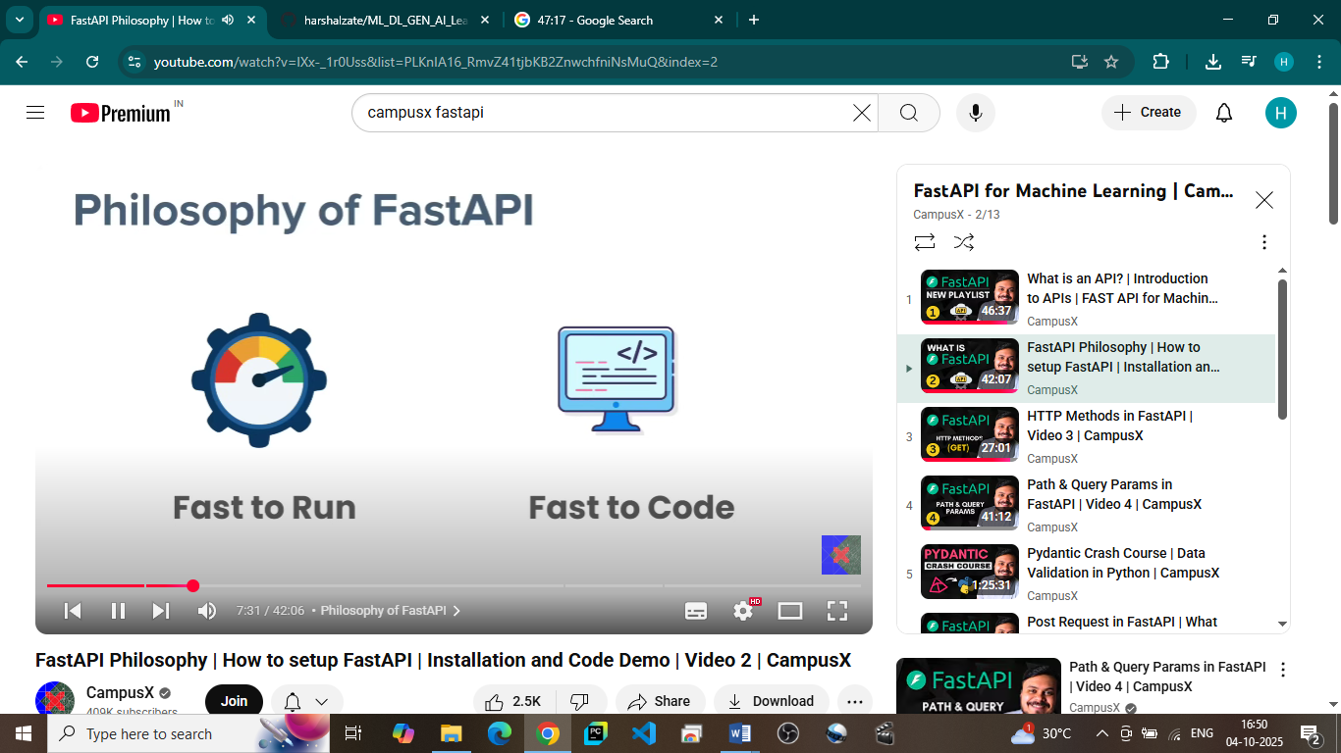
Why Fast API is fast to run?
First let’s understand how a traditional Flask APIs works.
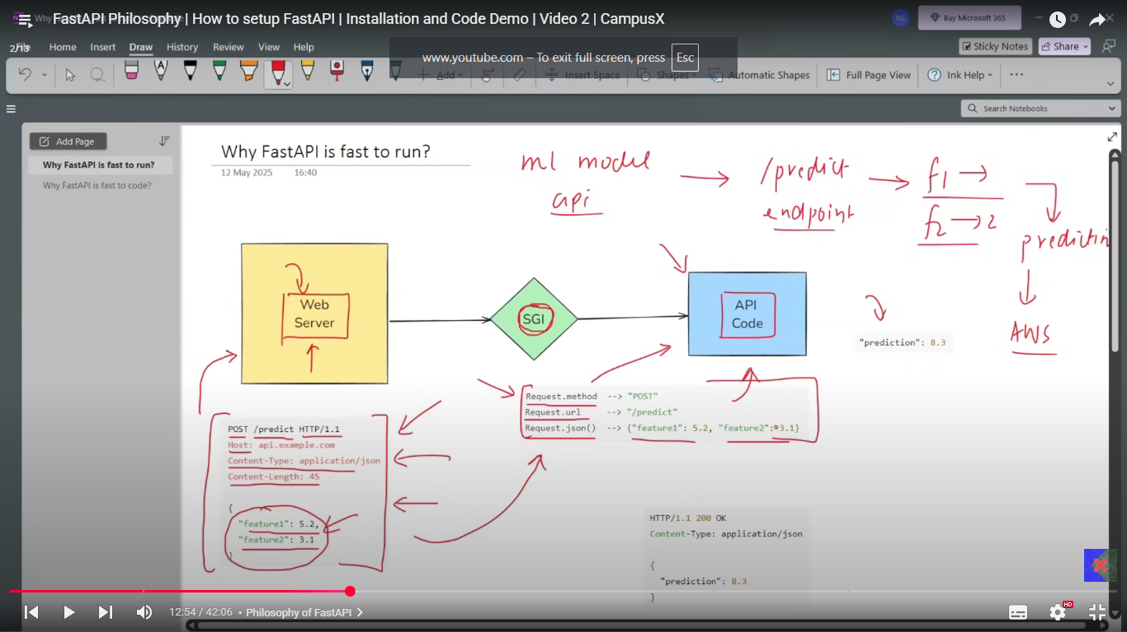
Web server handles the HTTP request including the input in HTTP request And the same request is sent to the API code, but the API code does not understand the http request so we have SGI (server gateway interface) in between which converts the http request into python understandable format which is then sent to the API code which understands the input and returns the output from backend then SGI again convert the python format output into http request and web server return the output in http response format.

Route: URL path + HTTP method mapping
Endpoint: The function (handler) that runs when the route is hit.

Flask API vs Fast API
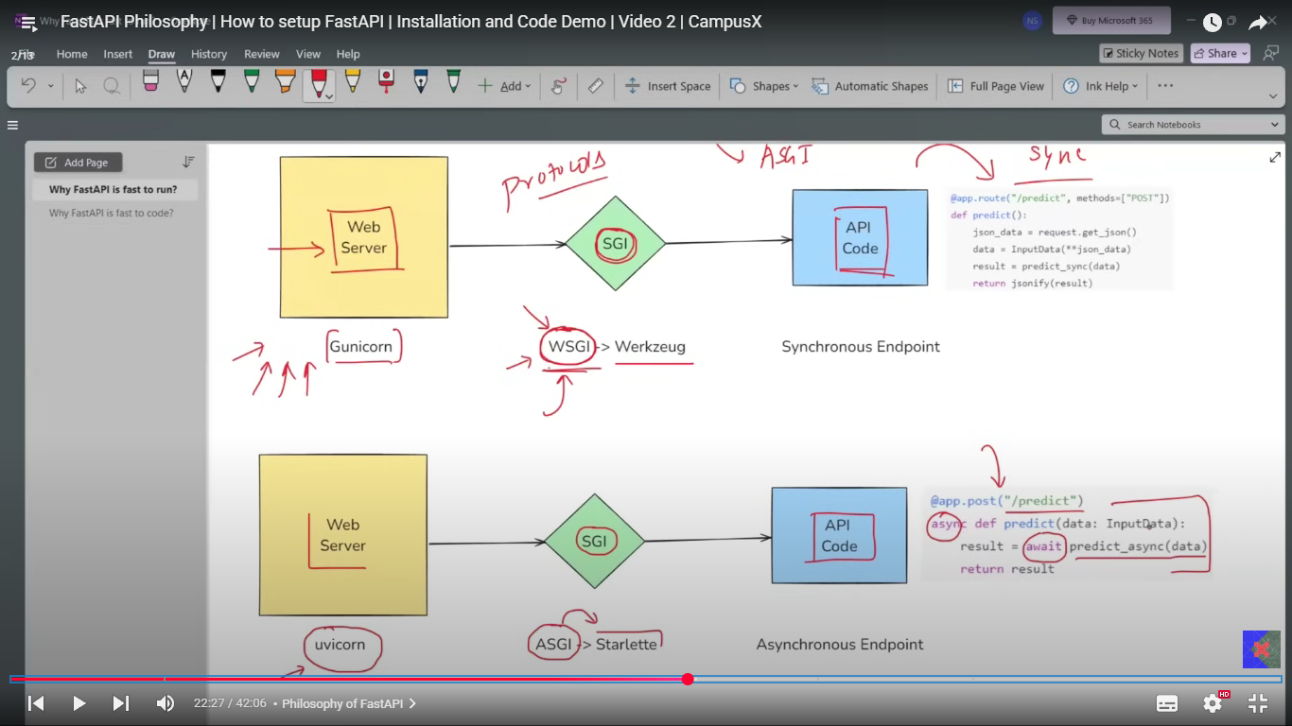

The flow elements are same in both which are Web Server, SGI and then API code except the SGI is WSGI in flask and SGI is ASGI in Fast.
Framework | Web Server(s) | Interface Name | Key Properties
Flask | Gunicorn, uWSGI, Waitress, gevent | WSGI | Synchronous, mature, stable, suited for traditional apps, handles HTTP only, widely supported, easy to use
FastAPI | Uvicorn, Daphne, Hypercorn | ASGI | Asynchronous, supports HTTP/1.1, HTTP/2, WebSocket, high concurrency, real-time protocols, modern async support

Flask and FastAPI are both powerful Python web frameworks with different focuses. Flask uses the synchronous WSGI protocol and popular web servers like Gunicorn and uWSGI, making it well-suited for traditional, simpler web applications and quick prototypes. FastAPI utilizes the modern asynchronous ASGI protocol with ASGI servers such as Uvicorn and Daphne, providing native async support for higher concurrency, WebSockets, and real-time features. FastAPI is designed for high-performance APIs and microservices, supporting automatic validation and documentation, while Flask offers great flexibility and mature ecosystem support. In summary, Flask is ideal for synchronous, straightforward apps, whereas FastAPI excels in async-heavy, scalable applications with modern protocol features. Both frameworks rely on their respective gateway interfaces (WSGI for Flask and ASGI for FastAPI) to mediate between the web server and the Python API code.
- pip install fastapi uvicorn pydantic
Installing the dependencies
- uvicorn main:app –reload
Run the file, with main as file name app as fastapi object and –reload to auto reload the API page on saving the python file.

Project:
Maintain patient data with all the personal and medical details of the patient as would be mentioned on the case paper. And we’ll create this endpoints.
/create
/view
/view with patient_id
/update with patient_id
/delete with patient_id

HTTP methods:
- Static software → Fixed, precompiled, predictable; same behavior for all users (e.g., Notepad, Minesweeper).
- Dynamic software → Adaptive, changes at runtime based on input or context (e.g., YouTube, Gmail).
- HTTP methods are the set of request types that define what action a client wants to perform on a resource (like data) over the web.
- There are four types of interaction usually you perform on the software applications which are CRUD, these interactions are not directly possible on website application as websites are installed on somewhere else unlike traditional software. So the communication for these 4 interactions happens through a protocol called as HTTP protocol with 4 verbs, each for one kind of application
  - GET – Retrieve
  - POST – Create
  - PUT – Update
  - DELET – Delete

2.1 GET method (Retrieve):
Path parameters
In FastAPI, a route is the URL pattern with an HTTP method, and an endpoint is the function that handles it. Path parameters are dynamic values defined in the route using curly braces (e.g., /items/{item_id}), and FastAPI automatically passes them as arguments to the endpoint function with the same name (e.g., def read_item(item_id: int)). If you don’t include {item_id} in the route, FastAPI won’t treat it as a path parameter, and the function will instead expect it as a query parameter (e.g., /items/?item_id=5). Thus, path params must always be specified in {} in the route and matched by name in the endpoint function.

POST method (Create):

PUT (Update):

Delete (Delete):

Improvements in API codes

Docker:
Every Docker file must start with a FROM instruction, which specifies the baseline prebuilt image that your new image will be built upon. For example, FROM python:3.9 tells Docker to use the official Python 3.9 image as the base, which already includes Python 3.9, and its standard libraries installed. This base image acts as the starting environment, providing essential runtime and system components. All subsequent Dockerfile instructions customize this base image by adding your application code, installing extra dependencies, setting environment variables, exposing ports, and defining the command to run your app. When you run docker build, Docker executes these instructions in order, layering changes on top of the base image to create a new image that can be deployed as a container. The base image eliminates the need to install core software like Python every time you build or run a container, ensuring consistency and saving time. Thus, the FROM instruction sets the foundation, and the rest of the Dockerfile builds a specific environment tailored to your application.
- FROM [base-image]:
  - Specify the base image to start with, e.g., FROM python:3.9 or FROM ubuntu:20.04. This is mandatory and establishes the environment your image will build on.
- WORKDIR [directory]
  - Set the working directory inside the image for subsequent instructions. For example, WORKDIR /app.
  - The working directory in Docker, set by the WORKDIR instruction in a Dockerfile, defines the directory inside the container where all subsequent commands (like RUN, COPY, CMD, and others) will be executed. It simplifies path management by providing a consistent context, so you don’t have to specify full absolute paths repeatedly. If the specified directory doesn’t exist, Docker creates it automatically. Using WORKDIR helps keep the Dockerfile clean and avoids mistakes related to file paths. For example, by setting WORKDIR /app, all following instructions will operate relative to the /app directory inside the container, making it easier to organize and manage your application’s files and commands efficiently.
- COPY [source] [destination]
  - Copy files or directories from your local machine into the image at the specified destination, e.g., COPY. . copies current directory to the container's working directory. Files are copied from build context which path is specified.

- RUN [command]
  - Run shell commands in the image during build, commonly used to install packages or dependencies, e.g., RUN pip install -r requirements.txt.
  - The RUN instruction in a Dockerfile is used to execute shell commands during the image build process. These commands are typically used to install software packages, dependencies, create files or directories, or perform any setup needed to prepare the image's environment. Each RUN command runs in its own intermediate container and creates a new layer in the final Docker image, capturing the changes made by that command. For example, a Dockerfile line like RUN pip install -r requirements.txt executes the pip install command at build time, installing Python packages into the image. This means all such commands are executed once when the image is built, and their results are saved inside the image layers. When you later run a container from this image, these installations and setups do not run again; the container simply starts with everything already in place as defined by the executed RUN commands during build. This makes the image a ready-to-use environment, while RUN instructions help set up that environment layer by layer.
- ENV [key]=[value]
  - Set environment variables inside the image.
Environment variables are dynamic, named key-value pairs stored within the operating system that influence the behavior and configuration of running applications or processes. Unlike normal variables used in programming, which exist only within the scope of a program or script, environment variables exist outside the program and can be accessed system-wide by multiple processes or applications. They enable configuration settings—such as file paths, credentials, or modes—to be set externally without modifying application code, promoting flexibility and security. This makes environment variables a critical mechanism for defining the operating environment in which programs run, allowing them to adapt dynamically based on the system or user context.
  - In the context of Docker, environment variables are used to configure and customize containerized applications without changing the Docker image or application code. They allow passing important settings such as server names, ports, file paths, API keys, or database credentials directly into the container at runtime. This makes the same Docker image reusable in different environments (e.g., development, testing, production) by simply changing environment variable values. Environment variables can dynamically control container behavior, override default application settings, and securely pass sensitive information like passwords or tokens (though secrets management is recommended for strong security). They can be set in the Dockerfile using ENV, passed during container startup with docker run -e, or managed in .env files and Docker Compose configurations. This flexibility and separation between app code and configuration is a core benefit of using environment variables in Docker.

- EXPOSE [port]:
  - Declare the port(s) the container will listen on when running. The EXPOSE [port] instruction in a Dockerfile declares that the containerized application inside the image listens on the specified port(s) at runtime. However, it is mainly informational and serves as documentation for developers and Docker tools to indicate which ports the container intends to use. It does not actually publish or open those ports to the host system by itself. To make a container’s port accessible from outside (e.g., the host machine or other networks), you need to explicitly publish it when running the container using the -p or --publish flag with docker run (e.g., -p 8080:80 maps host port 8080 to container port 80). The EXPOSE command helps with container networking planning, orchestration, and internal communication between containers but does not create external network access on its own. So, exposed ports are like a declaration of intent inside the image, while publishing ports is the action required to open network access externally.
- CMD [command] or ENTRYPOINT [command]
  - Specify the default command or executable to run when the container starts
  - Yes, CMD ["python", "app.py"] in a Dockerfile is effectively equivalent to running the command python app.py in a terminal, but with a key difference in how Docker executes it. In this JSON array form, Docker runs the executable python directly with app.py as an argument without invoking a shell. It does not concatenate them into a single string command like python app.py passed to a shell (/bin/sh -c). This direct execution is more efficient and avoids shell-related issues such as word splitting or signal handling problems. So, functionally it means "run the Python interpreter with the script app.py," just like typing python app.py in a terminal, but under the hood, it's executed as a direct command with arguments rather than a shell command string
  - In a Dockerfile, most commands like RUN, ENV, COPY, etc., are executed during the image build process to set up the environment and install dependencies. These commands create the Docker image layers and prepare the image for use. However, the commands specified by CMD or ENTRYPOINT are not executed during image build; instead, they define the default command or executable that runs only when the container is started from that image. So, CMD and ENTRYPOINT instructions are executed at container runtime, while the other Dockerfile commands run at image build time.

